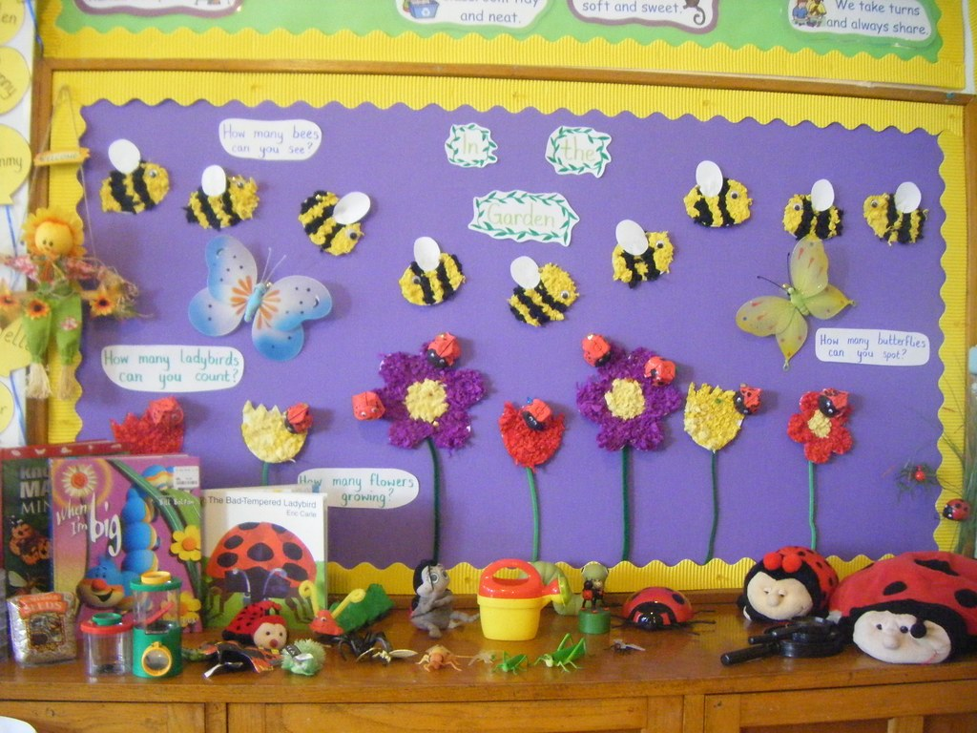
Nursery News May 2024

Monthly Topic
This month our topic will be Minibeasts.
We will be observing caterpillars change into butterflies. We will also focus on Jungle Animals.

Sponsored Trike Ride
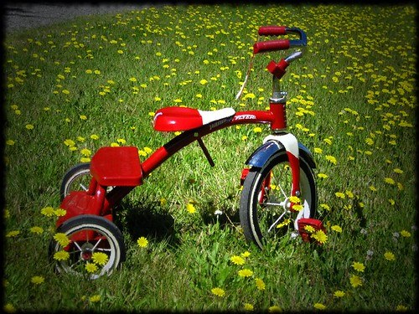
Our annual sponsored trike ride will be held on Thursday 9th May (Miss Cowan's Class) and Friday 10th May (Mrs Pollock's class), weather permitting, at 12:45pm each day. Please come and support your child and their class friends. This event is open to all the family to spectate.

This is our main fundraising event in the nursery year. All monies raised will be going towards purchasing an Interactive White Board for use in the classrooms. Any sponsorship money can be put in an envelope and given to either the class teacher or dropped into Michelle in the office.

Squares still available on our raffle! This fundraising event is to help towards purchasing an Interactive White Board. There are some great prizes! and at only £5 a square ... you have to be in to win!

Important Items to Note
- As the weather hopefully starts to change and we get to enjoy some sunshine, we would ask if you could please ensure that your child has some sunscreen protection on coming to school. If you do not wish staff to reapply sun cream later in the day, please inform us via Seesaw.
- Sunhats are available to buy at £3. Please see Michelle in the office if you wish to purchase one.
- If your child will be finishing nursery early (before 28th June) please advise Mrs Pollock or Miss Cowan.

We remind parents that if your child has a high temperature or has had diarrhea/vomiting, infectious diseases he/she must be kept at home for 48 hours to minimize the spread of infection within the nursery. Your child will be sent home if they are unwell.

MENU IS SUBJECT TO CHANGE
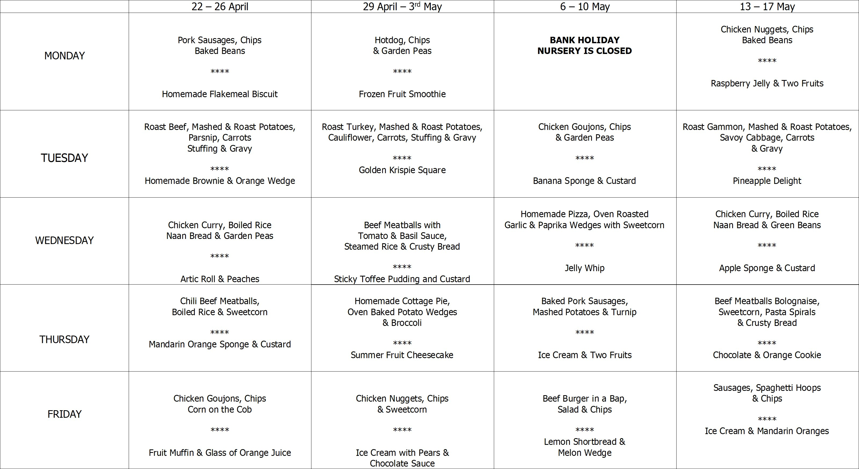

Safeguarding Team
- Mrs Pollock Designated Teacher
- Miss Cowan Deputy Designated Teacher
- Mrs Ball Chair of Governors
- Mrs Magee Governor for Child Protection

- Friday 3rd May - Educational visit from Wee Critters. £2.50 donation to be paid via Eduspot.
- Monday 6th May - Nursery closed for Bank Holiday Monday.
- Thursday 9th May - Miss Cowan's class Sponsored Trike Ride at 12:45pm (weather permitting).
- Friday 10th May - Mrs Pollock's class sponsored Trike Ride at 12:45pm (weather permitting).
- Monday 13th May - Class Photographs. All children to be in uniform.
- Tuesday 14th May & Wednesday 15th May - Mrs Elliott will be teaching Mrs Pollock's class as she will be meeting parents of next year's intake.
- Friday 24 May - Staff Development Day. Nursery will be closed to all children.
- Monday 27th May - Nursery closed for Bank Holiday Monday.

Minibeast Hunt
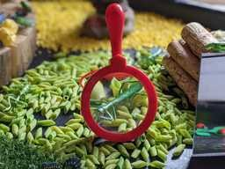
Go into your garden or park and look for bugs.
Take an old yoghurt pot to put them in.
Can you find any of the following :
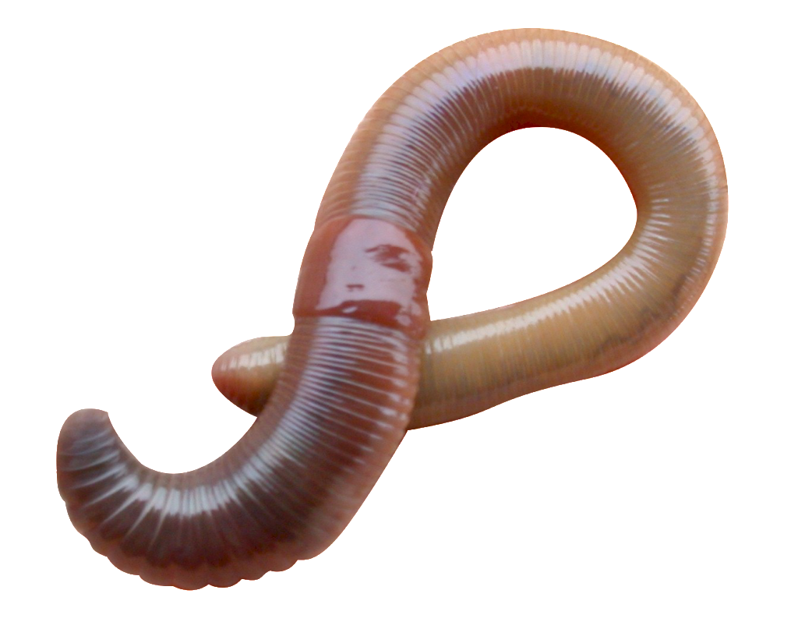
1 - Worm
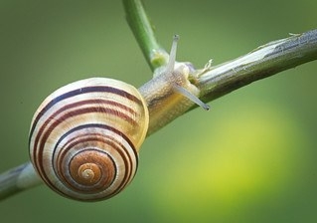
2 - Snail
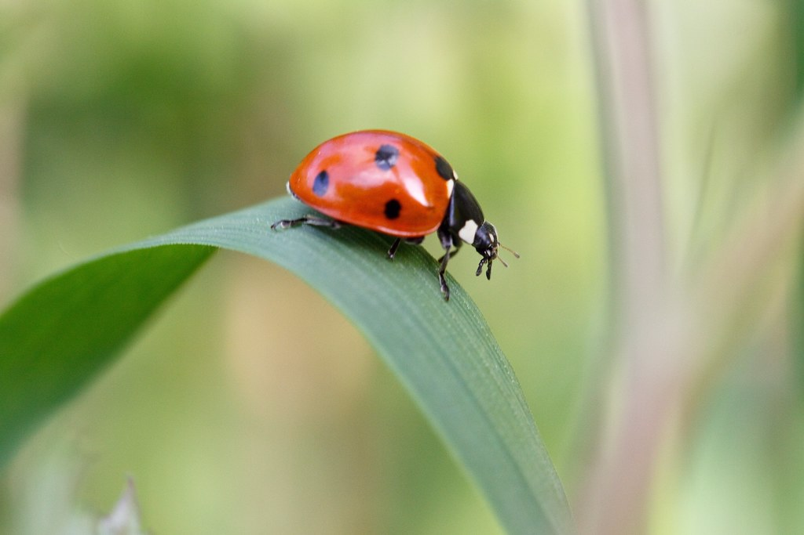
3 - Ladybird
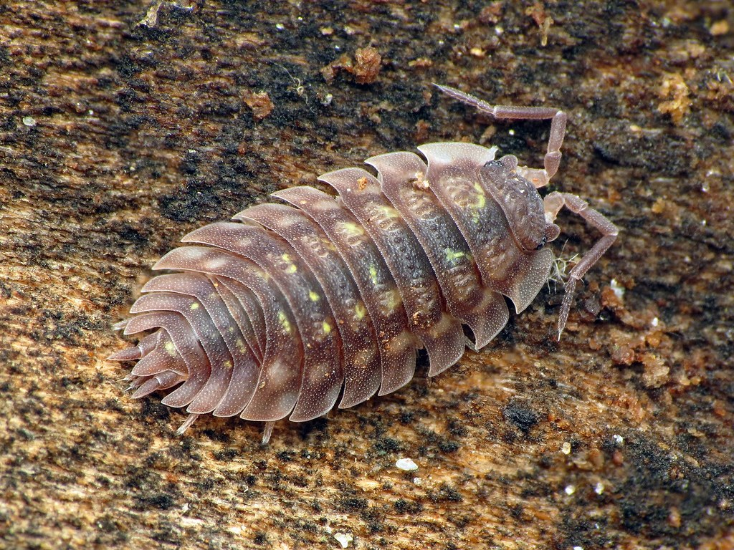
4 - Woodlouse
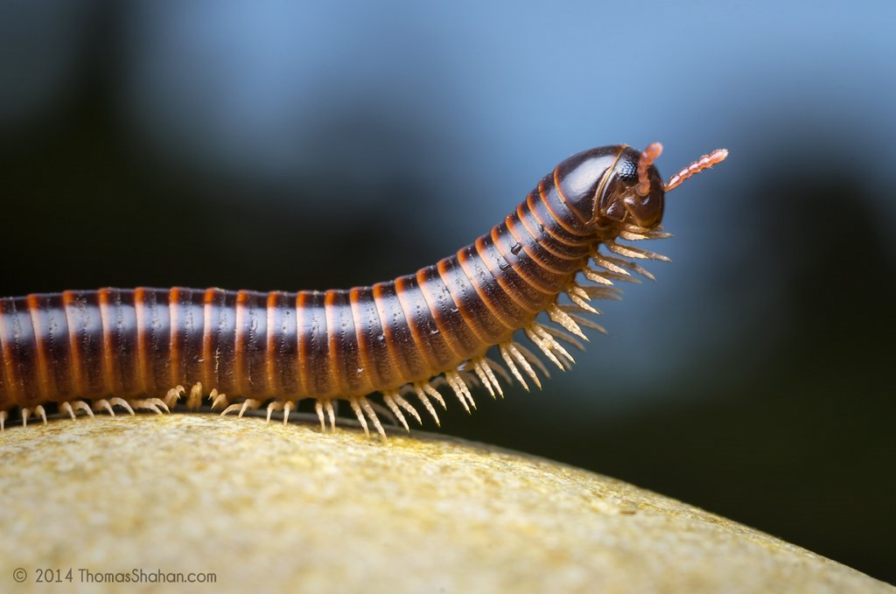
5 - Millipede

